2026 Spring Bird Count Preliminary Results
Joe Suchecki – DuPage County Compiler
The annual Spring Bird Count was conducted on Saturday May 9th, when over 100 DuPage birders spread out across the county to participate in this statewide event. The weather during the count was just about perfect with mild temperatures and fair skies. With good conditions, our very skilled DuPage birders were expecting a good count for the day.
In all, birders tallied 180 species and over 25,000 birds for the count. The 180 species was slightly above the average number of species seen over the last 20 years and tied the results from last year. Our most commonly seen birds were the Red-winged Blackbird, American Robin, Canada Goose, Tree Swallow, and House Sparrow. That list of the five most common birds has pretty much stayed the same over the last few years.
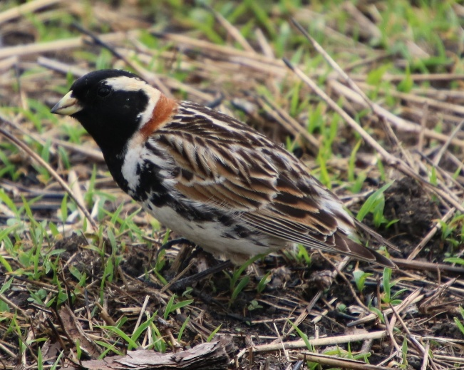
One of the fun aspects of birding is going out with expectations of finding some interesting or rare birds, and our fellow spring bird counters came up with some good ones for this year’s count. Topping the list of rare birds is the addition of a Lapland Longspur to the Spring Bird Count list. Diann Bilderback discovered a beautiful male longspur at Northside Park in Wheaton (see photo). This is the first record of a Lapland Longspur on the Spring Bird Count after over 50 years of completing spring counts in DuPage County. Congratulations to Diann for finding this great bird in a very unlikely location for a longspur.
Lapland Longspur. Photo by Diann Bilderback
Birders were also successful in recording some previously seen rarities on count day. The Western Tanager at Elsen’s Hill was relocated on count day as were the Loggerhead Shrike and Western Meadowlark at Fermilab. Additional birds requiring documentation for the count include a flock of 41 White Pelicans independently observed flying overhead by Denis Kania at McDowell Grove in Naperville and Pete Moxon at Elsen’s Hill in Winfield. We only get to count them once though. Thirty-three Monk Parakeets were seen at their regular location representing an all-time high number for this species on the count. Other notable species were Long-billed Dowitcher, King Rail, and Blue Grosbeak.
My thanks to the Area Captains and everyone who participated in the Spring Bird Count this year. I am still compiling the detailed results of the count at this time. We will provide more detailed information and a complete list of species and numbers of birds on the DBC website and in the July issue of Drummings.

